Short technical summaries
(what these extractors output and how)

OpenPose [7] — bottom-up, Part Affinity Fields
- What it outputs: per-frame 2D keypoint coordinates for body (and optionally face/hands/feet), confidence/score maps for each keypoint, and Part-Affinity Fields (PAFs) that encode which keypoints belong to the same person. OpenPose produces standard keypoint locations + confidence values.
- How it works (brief): bottom-up network predicts heatmaps (per-part confidence) and PAF vector fields; a parsing step groups parts into person skeletons. It's real-time and widely used as a general 2D keypoint extractor.

AlphaPose [13] —
high-accuracy whole-body, tracking, top-down style system
What it outputs: 2D keypoint coordinates and confidence for whole-body keypoints (body + hands + face + feet), and it includes tracking (PoseFlow / identity embeddings) to keep person IDs across frames. AlphaPose can supply COCO-style body keypoints (17 joints) or denser whole-body keypoints depending on configuration.
How it works: AlphaPose uses techniques such as Symmetric Integral Keypoint Regression (SIKR), parametric pose NMS (P-NMS) and identity embeddings for tracking; it is designed to be fast and accurate for multi-person, whole-body estimation.

Exact COCO 17 keypoint order
(to match ViMo’s J2d = 17)
COCO’s standard keypoint indices map to body parts in this order: [nose, left_eye, right_eye, left_ear, right_ear, left_shoulder, right_shoulder, left_elbow, right_elbow, left_wrist, right_wrist, left_hip, right_hip, left_knee, right_knee, left_ankle, right_ankle]

What the visibility ‘v’ means (COCO annotation semantics)
COCO encodes ‘v’ as an integer indicating whether a keypoint was labelled and whether it was visible in the annotation:
- v = 0 → keypoint not labeled / out of image (not annotated).
- v = 1 → keypoint labeled but not visible (occluded / not clearly visible).
- v = 2 → keypoint labeled and visible.
This is COCO’s annotation visibility flag, not a detector confidence score. COCO’s v is a ground-truth annotation visibility/label flag stored with dataset annotations.

- Pose detectors (OpenPose / AlphaPose / others) produce predicted (x,y) coordinates and a confidence/score for each predicted keypoint (a float probability / score). ViMo’s phrasing “predicted coordinates and confidence” refers to those detector outputs (per-keypoint scores), not to the COCO annotation v.
- So, in practice: when ViMo says COCO format + predicted coordinates and confidence, the pipeline is usually: Run AlphaPose/OpenPose → get per-frame (x,y,score) per keypoint (detector output). Pack those into the same per-keypoint structure (x, y, confidence) aligned to the COCO joint ordering to feed the model.

The shape m ∈ $R^{\{S × (24×6+4+3)\}}$ —
decode the numbers (step-by-step)
ViMo writes the target 3D motion vector per frame as having three parts:

Joint rotations in 6D:
- J3d = 24 (they use 24 joints in the 3D skeleton).
- C = 6 → each joint rotation is represented by 6 numbers (6D rotation representation packs each joint’s 3D orientation into 6 numbers in a way that’s continuous and easy for neural nets to learn, refer "On the Continuity of Rotation Rep.s in Neural Network" paper).
- So joint-rotation portion per frame = 24 × 6 = 144 numbers.

Foot contact labels ($R^{4})$:
A short binary vector of length 4 (so +4). ViMo says they precompute binary foot contact labels ${\{0,1\}}^{\{N×4\}}$ from foot/toe velocity near zero (i.e., whether each foot or toe is in contact with ground). This is important for physical plausibility (foot sliding, planting).

Root position $(R^{3})$:
A 3D global root position (x,y,z) for the body root (global translation), so +3. ViMo explicitly stores the global position of the root joint along with rotation.
Add them up: 144 (rotations) + 4 (foot) + 3 (root) = 151 scalars per frame. If sequence length is S frames, the full motion is S × 151. ViMo denotes this compactly as S × (24*6+4+3).

Foot contact labels and root position — made easy
- Foot contact labels (4 numbers): these are binary flags telling whether each foot/tip is touching the ground at that frame (e.g., left foot, right foot, left toe, right toe) — used to avoid feet sliding and to make motion physically plausible. ViMo computes them from the foot/toe vertical velocity being near zero.
- Root position (3 numbers): the global (x,y,z) location of the body’s root (usually pelvis or hips). This controls where the character is in world space so the motion is not just orientation but also translation.

Overview:
- Diffusion models (Denoising Diffusion Probabilistic Model - DDPMs): imagine you take a clean motion (a whole mocap clip) and progressively add a little Gaussian noise to it over many steps until it becomes almost random noise. That’s the forward / noising Markov process.
- Then you train a neural network to reverse that corruption: starting from pure noise, step-by-step remove noise until you get back a plausible clean motion. That’s the reverse / denoising learned process.
- Conditioning: ViMo gives the network extra input — the 2D pose sequence from the video — so the denoiser produces 3D motion that matches the 2D pose rhythm/shape.
- Important: the diffusion time-step ‘t’ here means how noisy a sample is (not the video time axis). The whole motion sequence (many frames) is corrupted together at each diffusion level and denoised together — the model is sequence-aware (transformer) and predicts the full 3D motion sequence from noisy input plus 2D condition.

What is a Markov noising process?
- Markov: each noisy state only depends on the previous noisy state (not the entire history). Formally:
- Noising: at each step we add Gaussian noise with a prescribed variance schedule. Over many steps the clean data becomes dominated by noise.

The forward (noising) process:
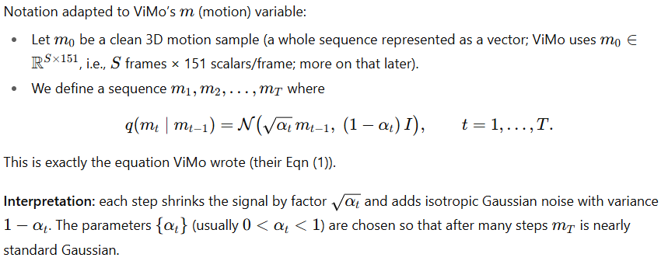

Closed-form expression for m_{t} in terms of m₀
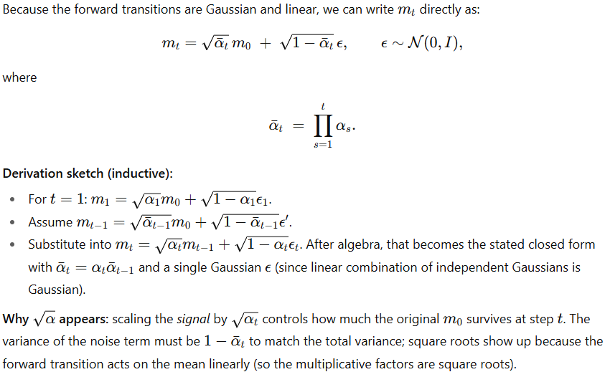

Derivation of the closed-form forward noising formula:
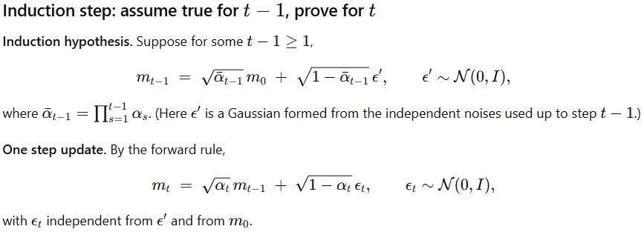
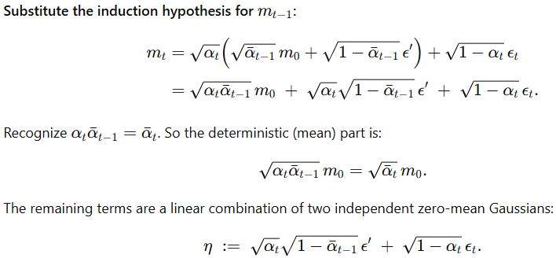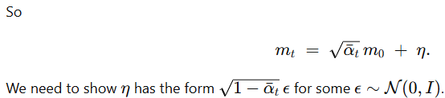
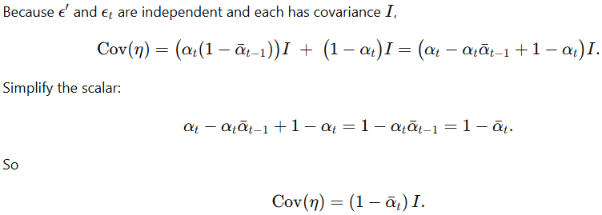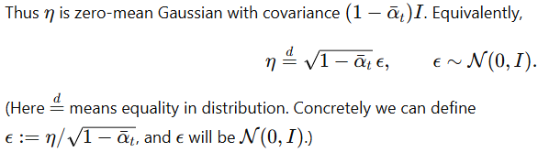
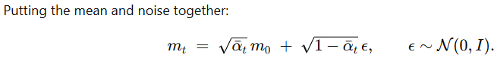
Key observations:
- Why sqrt(α_{t})​​ multiplies the previous mean: the forward Gaussian transition scales the mean (signal) by sqrt(α_{t})​​ at each step; sequential application multiplies these scalings, producing sqrt(αˉ_{t}) ​​in the closed form.
- Why the noise combines into a single Gaussian: linear combinations of independent Gaussian variables are Gaussian; their covariance adds. The specific scalar sqrt(1−αˉ_{t}) ​​ is forced by matching the total variance to 1−αˉ_{t}.
- Practical meaning: at diffusion step ‘t’, a fraction αˉ_{t} ​ of the original signal survives in the mean, and the remaining variance 1−αˉ_{t}​ is pure Gaussian noise.
clarify notation:
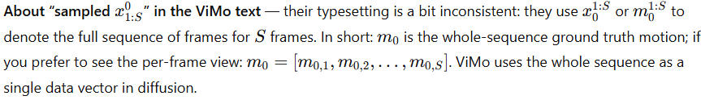

Where does the 3D ground truth M come from (if dataset is videos)?
- ViMo’s training requires paired data: videos with corresponding 3D motions. In their experiments they train on datasets that do provide 3D mocap aligned with videos
- For videos that don’t have ground-truth 3D (the casual videos the paper targets), ViMo’s goal is to generate plausible 3D motions conditioned on the video’s 2D poses
- In short: training uses datasets with GT 3D; inference can run on plain videos (2D poses only) to produce 3D.
- So, when the paper writes m ∼ q(M∣p) they mean: the data distribution over 3D motions conditional on 2D pose sequences (during training we have examples from real dataset pairs (p, m0).

The reverse (denoising) process and the posterior q(m_{t−1}∣m_{t},m₀):
Because the forward process is Gaussian and linear, the true posterior q(m_{t−1}∣m_{t},m₀) is also Gaussian** with known mean and variance. That posterior is used in deriving what the neural denoiser should predict. (** how? Refer below)
Using the standard DDPM formulas: (explained below)
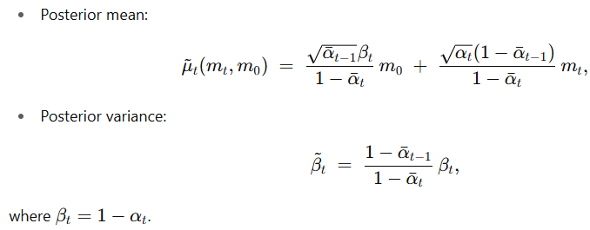
This is the exact Gaussian The denoiser network approximates the reverse conditional usually by predicting parameters (a mean) used to sample the next less-noisy state.
Takeaway: the posterior gives a ground-truth target for the reverse step if you know m₀​. In training, that forms the basis for objectives.

Derivation of the posterior:
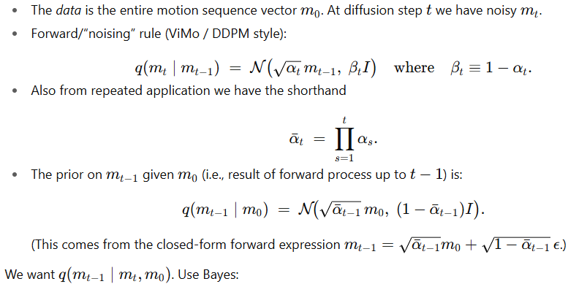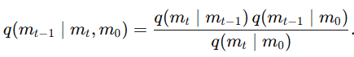
When treating this as a function of the unknown m_{t−1}​, the denominator q(m_{t}∣m₀) does not depend on m_{t−1}​ (it depends only on m_{t}, m₀), so it is a constant factor — it only changes the normalizing constant of the posterior, not its shape (mean/variance). Therefore, we can write:
and determine the posterior mean and covariance by matching the quadratic and linear terms in the exponent (completing the square). The normalization constant only matters if you need the exact probability value, not the mean/covariance.
Remember: Normal Distribution Formula: 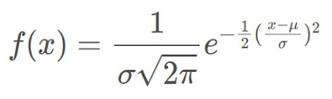
Normalization const --> e^{-1/2}/sigma*sqrt(2*pi) is not considered here.

Scalar case — explicit arithmetic:
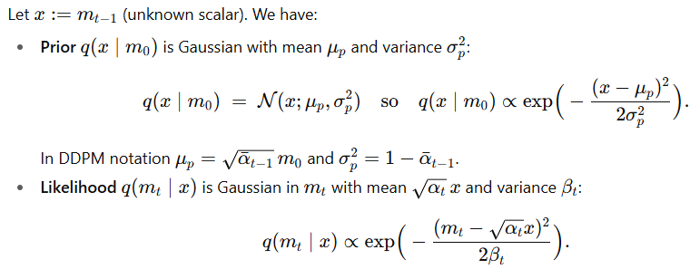
Multiplying two Gaussians (in the same variable) gives another Gaussian. To see its mean/variance, we just expand the exponent.
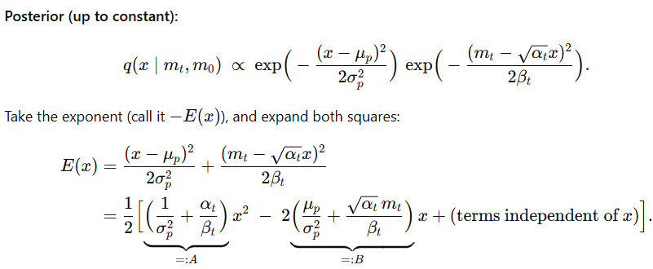
We know Gaussians look like 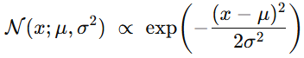. So, if we want to show that our posterior is Gaussian, we must massage the exponent E(x) until it has the form 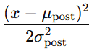. That means: get everything into “a square shifted around the mean.”
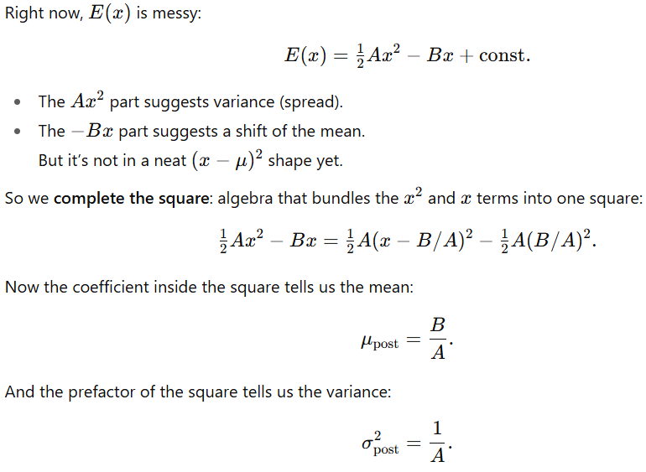
Simply put (in another way - easier):
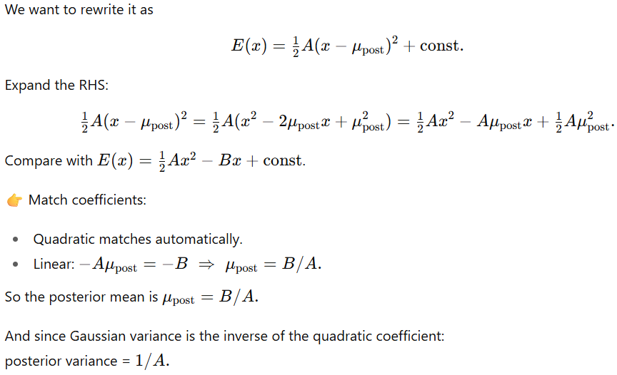
Why is this valid?
Because the exponential of a quadratic function is always Gaussian. Completing the square is just a way of identifying the mean and variance hidden inside that quadratic.
The extra constant (like ) only changes the overall scaling of the density. That scaling gets absorbed into the normalizing constant so the PDF integrates to 1. It doesn’t affect mean/variance.
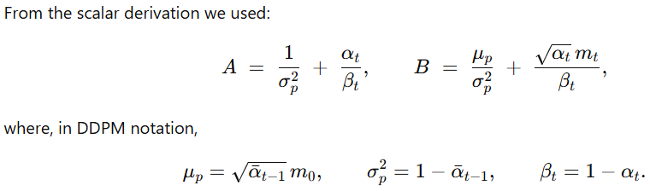
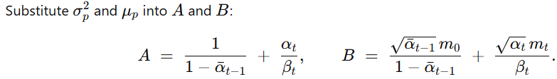
Compute 1/A (posterior variance):
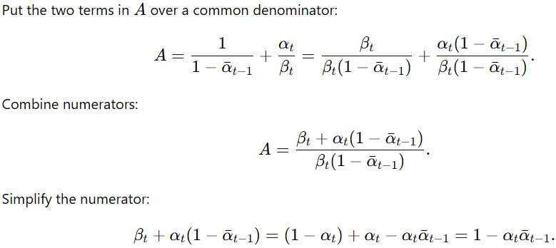
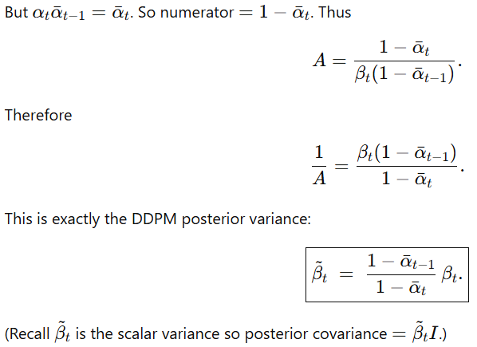
Compute B/A (posterior mean):
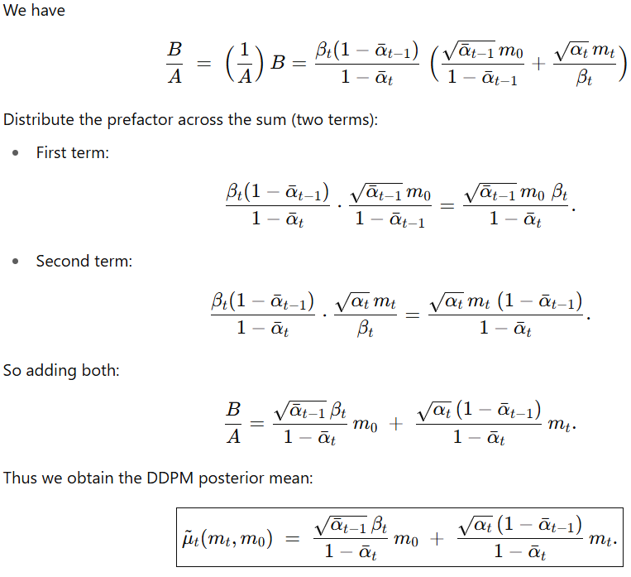
Two different kinds of “constants”
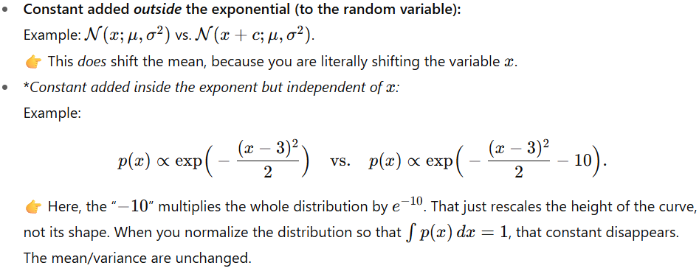
Key point: At no place did we need the marginal q(m_{t}∣m₀) because we were only manipulating the exponent (which depends on x) — the marginal is a multiplicative constant independent of x.

Vector case (matrix notation) — same idea but compact:
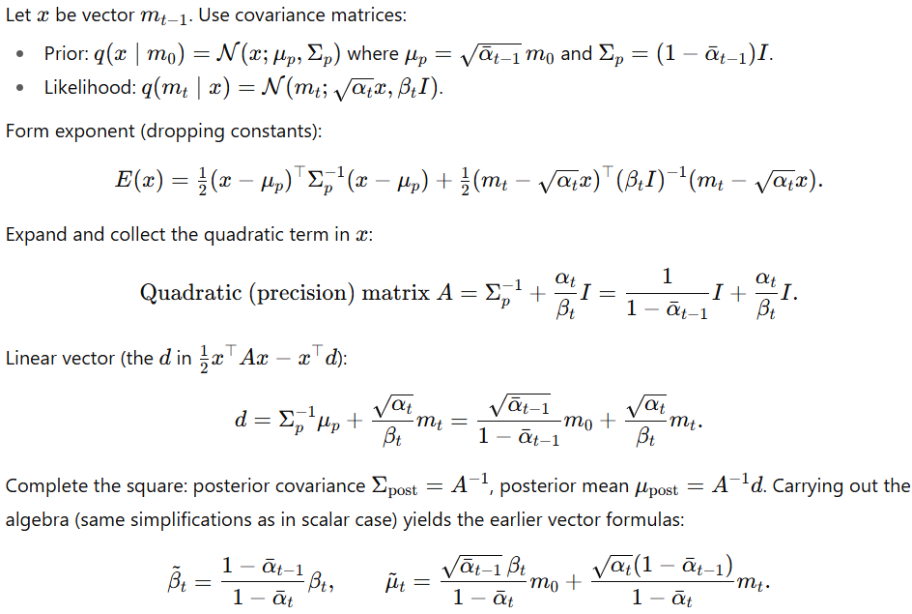

Training — epsilon-prediction vs x₀-prediction
This is where many papers differ; ViMo’s text explicitly says they predict the motion itself directly, not a re-parameterized epsilon. Let me explain both formulations and how they relate.
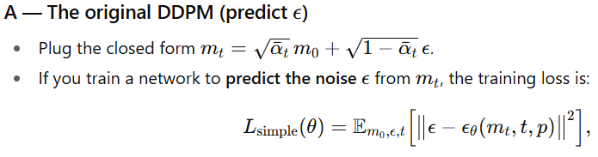
where ϵ_{θ} is the network’s output. This is the objective used in Ho et al. It tends to be numerically stable and has good properties.
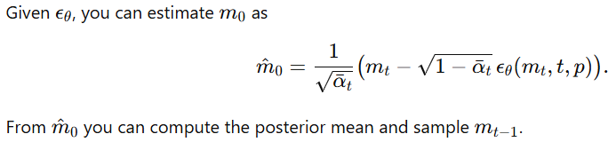
(just substitute ϵ_{θ} in closed form eq. along with all other known parameters and m₀ we obtain is the estimate of the ground truth)
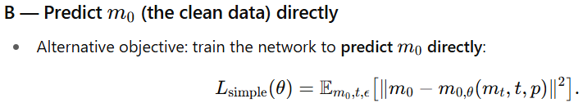
This is what ViMo states they do: “result motions are directly predicted rather than reparameterization of vanilla epsilon.” In other words, D(mt,t,p) outputs m^₀​ directly. The paper uses that L_{simple}​ form as exactly in Eqn (3).
Relation between the two: If you predict ϵ\epsilonϵ, you can compute m^₀; if you predict m^₀​, you can compute an implied ϵ^. They are convertible using the closed-form relation shown above. The choice (predict ϵ vs predict m₀​) is mostly an implementation/training-stability choice — some tasks benefit from direct m0m_0m0​ prediction because the target data structure is complex and you want the network’s last layer to output the clean structured data directly.
Why ViMo might prefer predicting m₀​: The target is a structured, multi-part vector per frame (6D rotations, foot contacts, root pos). Predicting the whole structured m₀​ directly may make it easier to include auxiliary losses (FK loss, velocity loss, foot loss — ViMo uses those) that are computed on the predicted motion itself. If the network predicts m^₀​ directly, those auxiliary losses can be applied straightforwardly. ViMo does combine the diffusion L_{simple} with auxiliary FK/vel/foot losses in Eqn (7).

“Reparameterization of vanilla epsilon” — what that means?
- “Vanilla epsilon” means the original DDPM parameterization where the network predicts the noise ϵ.
- A “reparameterization” refers to expressing the network’s output in a different variable (e.g., predicting m₀​ instead of ϵ) — they are interchangeable because of the closed-form relation between m_{t}, m₀ and ϵ.
- ViMo is telling you: we do not use the usual ϵ-prediction formulation; we directly predict m₀​. That’s just a modeling choice.

Does D(m_{t},t,p) output a “less noisy 3D mocap” and is that the posterior?
- D(m_{t},t,p) outputs an estimate of the clean motion m^₀​ (in ViMo’s design). From m^₀​ and the known forms (the posterior formula), we can compute the parameters for p_{θ}(m_{t−1}∣m_{t},p) (the denoising conditional distribution) and sample m_{t−1}.
- So: No, the network does not directly output the true posterior q(m_{t−1}∣m_{t},m₀). It outputs a quantity (here m^₀) that we can plug into the analytic Gaussian posterior formula to get a mean for m_{t−1}​. The actual posterior is known analytically only because the forward process is Gaussian and we know m₀​ exactly in training; the denoiser approximates it at sampling time via its predicted m^₀.
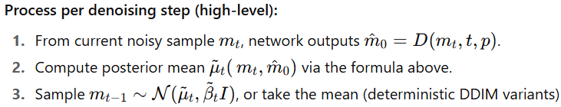
— this yields the next less-noisy sample.

Derivation example - to sample m_{t−1}
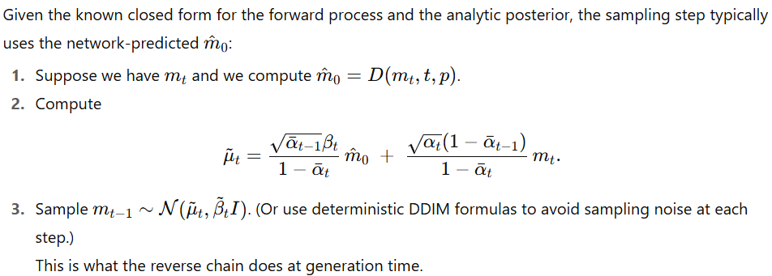

What is “time step” t in diffusion, and how does it relate to video frames?
- The diffusion time-step t ∈ {1, …, T} is not the video frame index. It is the index in the noise schedule that controls how strongly the data has been corrupted.
- Video frames (frame index) live inside the single data vector m₀​ (which encodes a whole sequence of S frames). The diffusion process corrupts the entire motion sequence m₀​ (all frames together) to produce m_{t}​. So, at each diffusion index t, you have a noisy sequence m_{t} representing the whole clip.
- Why corrupt the whole sequence at once? This allows the denoiser to exploit temporal dependencies (smoothness, rhythm) while denoising. If you noised and denoised frames independently you’d lose important temporal coherence.

FiLM Blocks (Feature-wise Linear Modulation)
A FiLM (Feature-wise Linear Modulation) layer is a dynamic form of a linear layer. Instead of having fixed weights, its "weights" are generated on-the-fly by a separate network based on an external condition.
A FiLM layer applies an affine transformation (scale and shift) to the input x, where the parameters γ (gamma) and β (beta) are functions of an external condition vector c.
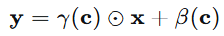 where:
- x is the input feature map (an intermediate activation in the denoiser network of shape).
- NOTE: this input (x) to FiLM is not Noisy 3D motion sequence (shape: n × q), but rather Intermediate features between multiple transformer blocks of Denoiser (say shape: n × d) where d is hidden layer’s dimension.
- Condition: c = [embed(t); encode(p)] (a concatenation of the timestep embedding and the encoded 2D pose sequence).
- γ(c) and β(c) are functions that map the condition c to scale and shift vectors.
- ⊙ denotes the Hadamard (element-wise) product.
Flowchart:
- Input: Noisy 3D motion sequence (shape: n × q)
- Multiple transformer layers
- Intermediate feature: x (shape: n × d) // d is hidden dimension
- FiLM modulation here
- More transformer layers
- Output: Denoised 3D motion (shape: n × q)
Simple Linear Layer: A Static Transformation (y = wx+b). The parameters W and b are static. They are learned during training and then remain fixed for every input during inference. They do not change based on the content of x or any external context.
- Dynamic vs. Static: γ and β are not fixed model parameters. They are the outputs of a neural network (f_{film}) that takes c as input. This means the transformation applied to x changes dynamically based on the condition. 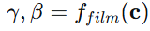
- Feature-wise Modulation: The operation γ ⊙ x + β is applied element-wise or channel-wise (for efficiency: per-channel modulation). If x is a feature vector of length D, then γ and β are also vectors of length D. This means each feature dimension in x can be individually scaled up, scaled down, or shifted. This is a much more fine-grained and expressive control mechanism than a full matrix multiplication.
Compute how the loss L depends on the FiLM parameters θ_{film} :
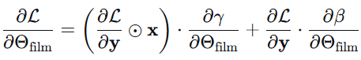
Dimensional Analysis: Let
- n = number of frames (S in paper)
- p = 2D pose dim per frame (e.g., 17 joints × 2 = 34),
- q = 3D pose dim per frame
(e.g., 24 joints × 6D rotations + root pos + contact = 151)
- A = embed(t), i.e., Timestep embedding
and a = dim(A) (say ~128 or 256)
- B = encode(n*p), i.e., encoded 2D poses.
  - Input: 2d poses of all frames (global video clip’s 2D skeleton trajectory).
  - Goes through an encoder network (likely a temporal transformer or CNN). This encoder produces a compact representation of the entire sequence. Say b = dim(B).
  - Ouput: variable (often projected to same 256–512 range)
- Thus c = [A;B] => dim(c) = a+b.
- Global Conditioning: The same γ, β are applied to all frames because the condition represents global properties of the entire sequence
- Efficiency: If FiLM output n × d parameters, it would require:
Input: (a + b) → Output: 2 × n × d
This is computationally expensive and could overfit.
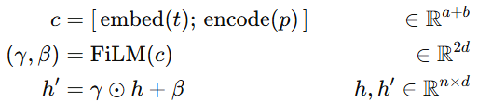

Conditioned vs. Unconditioned Generation
- Unconditioned Diffusion Model: You ask the artist to "create something." They generate a random image from the static. It could be a cat, a dog, a car—whatever they learned during training.
- Conditioned Diffusion Model: You give the artist an instruction. You say, "Create a picture conditioned on the word 'cat'." Now, the artist uses that instruction (the "condition") to guide the denoising process, ensuring the final image is a cat.
In ViMo:
- The Condition (c or p): The sequence of 2D poses extracted from the input video.
- The Goal: Generate a 3D motion that matches the condition (the 2D poses).

What is "Classifier-Free Guidance"?
The Old, Complicated Way (Classifier Guidance):
Early diffusion models (e.g., guided diffusion in 2021) used an external classifier to guide generation. Imagine you have two people:
- The Artist (Denoiser): Knows how to denoise images.
- The Harsh Critic (Classifier): A separate AI that is an expert at identifying images. You show it a picture and it says, "That is 95% a cat."
To generate a "cat" image, you would start with noise and have the artist make a small step. Then you'd ask the critic, "Does this look more like a cat?" You'd use the critic's feedback to push the image in the "more cat-like" direction. This is powerful but complex, as it requires training two separate models.

The New, Simpler Way (Classifier-Free Guidance):
You don’t train a separate classifier. Instead, you train a single diffusion model in two modes: You train only one model—the Artist—but you train it in two different modes:
- Conditioned on the input signal (here: the 2D pose): You show it a noisy image and the text "cat". It learns to denoise it into a cat.
- Unconditioned (the conditioning is randomly dropped, e.g. replaced by a null token) during training: You sometimes randomly drop the condition. You show it the same noisy image but with no text. It learns to denoise it into a random image.
So, the same network learns both “with conditioning” and “without conditioning.”
During Training: They randomly drop the 2D pose condition 25% of the time. This trains the model to also work in an "unconditioned" mode.
During Generation: They use the "classifier-free guidance" formula. The final output is a blend: 75% of the "conditioned" output (faithful to the video) and 25% of the "unconditioned" output (creative, diverse). This balances fidelity (sticking to the video) and diversity (creating natural, varied motions).
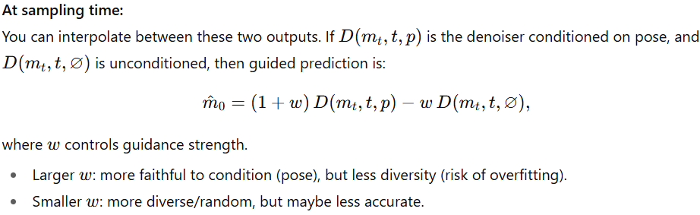

The 6D Rotation Representation:
- Joint Rotations (R) in 6D format: This represents the orientation of each bone in the skeleton relative to its parent bone in the kinematic tree. The 6D representation is a continuous, non-redundant way to represent a 3D rotation, which is easier for neural networks to learn than traditional Euler angles (which suffer from gimbal lock) or Quaternions (which have a unit norm constraint). Mathematically, a 3D rotation matrix $R_{3x3}$ can be approximated or represented by its first two column vectors, resulting in a 6D vector $[a_{1},a_{2}]$. The third column can be recovered as $a_{3}=a_{1}×a_{2}$.
- Root Position (root): The global 3D translation $(x,y,z)$ of the root joint (usually the pelvis). This defines the character's location in the world.
- Foot Contact Labels (f): A 4-dimensional binary vector indicating contact with the ground for the left foot, right foot, left toe, and right toe.
The 6D representation is a brilliant trick to avoid the problems of other 3D rotation parameterizations. Here's the step-by-step derivation.
Premise: A 3D rotation matrix $R∈R^{3×3}$ is a special orthogonal matrix. This means:
- $R^{T}R=I$ (Orthonormal columns and rows).
- $det⁡(R)=+1$ (Proper rotation, no reflection).
Step 1: The Column Vector Interpretation
Any matrix can be defined by its column vectors. Let's define $R$ as:
$\text{R = [}\begin{matrix}a_{1} & a_{2} & a_{3}\end{matrix}]$ where $a_{1},a_{2},a_{3}∈R^{3}$.
Step 2: Consequences of Orthonormality
From $R^{T}R=I$, we get the constraints on the column vectors:
- $∥a_{1}∥ = ∥a_{2}∥ = ∥a_{3}∥ =1$ (Unit length).
- $a_{1}⋅a_{2}=a_{1}⋅a_{3}=a_{2}⋅a_{3}=0$ (Mutually orthogonal).
Step 3: The Key Insight for the 6D Representation
The first two columns, $a_{1}$ and $a_{2}$, are two orthogonal unit vectors in 3D space. They define a plane. The third column, $a_{3}$, must be a unit vector orthogonal to this plane. There is only one such vector (up to sign, but the sign is fixed by the right-hand rule to ensure $det⁡(R)=+1$).
Therefore, the third column is uniquely determined by the first two:
$a_{3}=a_{1}×a_{2}$ , Proof: The cross product $a_{1}×a_{2}$ produces a vector that is:
- Orthogonal to both $a_{1}$ and $a_{2}$ (satisfying the orthogonality constraint).
- Has a magnitude of $∥a_{1}∥∥a_{2}∥sin⁡θ=1$ (since they are unit and orthogonal, $sin⁡{90}^{∘}=1$), satisfying the unit length constraint.
- Its direction follows the right-hand rule, ensuring a proper rotation matrix with $det⁡(R)=+1$.
Conclusion: We do not need to predict all 9 elements of $R$. We only need to predict the first two columns ($a_{1},a_{2}$), which form a 6D vector. The full, valid, orthonormal rotation matrix is then reconstructed without any approximation as: $\text{R = [}\begin{matrix}a_{1} & a_{2} & a_{1}×a_{2}\end{matrix}]$

Deconstructing the Loss Functions
The diffusion loss $L_{\text{simple}}$ ensures the model learns to denoise the data. The auxiliary losses $L_{\text{joints}},L_{\text{vel}},L_{\text{foot}}$ are applied to the model's final prediction of the clean motion at each denoising step, ${\hat{m}}_{0}=D(m_{t},t,p)$, to enforce physical plausibility and temporal coherence.
Let's define the notations clearly:
- $S$: The number of frames in the sequence.
- $R_{0}^{i}$: The ground truth joint rotations for frame $i$. The subscript ‘₀’ denotes the "clean" data at diffusion step $t=0$.
- ${\hat{R}}_{0}^{i}$: The model's predicted joint rotations for frame $i$ (extracted from ${\hat{m}}_{0}$).
- $FK(⋅)$: The Forward Kinematics function.
- ${\hat{f}}_{i}$: The model's predicted binary foot contact label for frame $i$.

3D Positions Loss ($L_{\text{joints}}$)
Equation:
$$L_{\text{joints}}=\frac{1}{S}\sum_{i=1}^{S}{{∥FK(R_{0}^{i})-FK({\hat{R}}_{0}^{i})∥}_{2}^{2}}$$
What it does: This loss ensures the model's predicted skeleton has the same 3D shape as the ground truth skeleton.
The Forward Kinematics (FK) Function: This is the core of this loss. The FK function is a deterministic, differentiable function that takes the predicted joint rotations $\hat{R}$ and the root position, and computes the resulting 3D joint positions in global space.
- How it works mathematically: The skeleton is a kinematic tree. The position of a joint $j$ is calculated by traversing the path from the root to $j$, sequentially applying the rotations of its parent joints.
  - Let the position of a joint $j$ be $p_{j}$.
  - Let its parent be $par(j)$, with a known bone vector $b_{j}$ in the parent's local coordinate system.
  - The global position of $j$ is: $p_{j}=p_{par(j)}+R_{par(j)}⋅b_{j}$
- Here, $R_{par(j)}$ is the global rotation matrix of the parent joint. This is found by recursively multiplying the local rotation matrices up the kinematic tree: $R_{j}=R_{par(j)}⋅R_{j}^{\text{local}}$, starting from the root.
- Why it's necessary: The model outputs rotations $\hat{R}$, but we ultimately care about the 3D mesh or joint positions. A small error in a root joint's rotation (e.g., the pelvis) can lead to a large error in the position of a leaf joint (e.g., the foot). $L_{\text{joints}}$ directly penalizes these end-effector errors, which are perceptually most important.

[Angular] Velocities Loss ($L_{\text{vel}}$)
Equation:
$$L_{\text{vel}}=\frac{1}{S-1}\sum_{i=1}^{S-1}{{∥(R_{0}^{i+1}-R_{0}^{i})-({\hat{R}}_{0}^{i+1}-{\hat{R}}_{0}^{i})∥}_{2}^{2}}$$
What it does: This loss enforces temporal smoothness and ensures the rate of change of the motion (its angular velocity) is correct.
Mathematical Interpretation:
- $(R_{0}^{i+1}-R_{0}^{i})$: This is the finite difference approximation of the first derivative (ang. vel.) of the rotation param.s in the ground truth motion.
- $({\hat{R}}_{0}^{i+1}-{\hat{R}}_{0}^{i})$: This is the ang. vel. of the predicted rotation parameters.
- The L2 norm of their difference ensures that the model not only predicts correct poses per frame but also correct transitions between frames. This is critical for eliminating jitter and producing natural, smooth motion.
Rotation Parameters Difference as Angular Velocity: This is a discrete approximation of the time derivative. Let's formalize it.
Step 1: Define the Quantity
Let $r(t)$ be the 6D rotation parameters of a specific joint as a continuous function of time $t$. The instantaneous rate of change (velocity in radians) of these parameters is the derivative $\frac{dr(t)}{dt}$.
Step 2: Discrete Approximation
In a discrete-time system (like our motion sequence with frames at times $t_{1},t_{2},...,t_{S}$), we approximate the derivative using finite differences. The forward difference approximation at frame $i$ is:
$$\frac{dr(t_{i})}{dt}≈\frac{r(t_{i+1})-r(t_{i})}{Δt}$$
where $Δt$ = time interval between frames (e.g., $Δt=1/30$ sec for 30 FPS).
Step 3: Simplification for Loss Function
In the loss function $L_{\text{vel}}$, we are comparing the difference between the predicted and ground-truth motions. Since $Δt$ is a constant positive scalar across all sequences, it can be factored out and absorbed into the loss weight $λ_{2}$. Therefore, minimizing the difference in the unnormalized finite differences $(r_{i+1}-r_{i})$ is equivalent to minimizing the difference in the approximated velocities.
Mathematically:
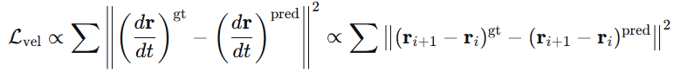
This loss ensures that the change in the joint's rotational state between frames is correct, which is a direct measure of its angular velocity in the parameter space.

Foot Contact Loss ($L_{\text{foot}}$)
Equation:
$$L_{\text{foot}}=\frac{1}{S-1}\sum_{i=1}^{S-1}{{∥(FK({\hat{R}}_{0}^{i+1})-FK({\hat{R}}_{0}^{i}))⋅{\hat{f}}_{i}∥}_{2}^{2}}$$
What it does: This is a physics-based loss designed to eliminate "foot sliding," a common artifact in generated motions where the feet slide unnaturally on the ground during steps.
Mathematical Deconstruction:
- $FK({\hat{R}}_{0}^{i+1})-FK({\hat{R}}_{0}^{i})$: This is the 3D displacement (velocity vector) of all joints between frame $i$ and $i+1$, calculated from the predicted poses. Let's call this $v_{\text{joints}}^{i}$, a matrix where each row is the velocity vector for a specific joint.
- ${\hat{f}}_{i}$: This is the model's own prediction of the binary foot contact label for frame $i$. It's a 4D vector, e.g., $[1,0,1,0]$ meaning the left foot and left toe are in contact with the ground, while the right foot and toe are not.
- The Hadamard Product $⋅$: This is an element-wise multiplication. The operation $v_{\text{joints}}^{i}⋅{\hat{f}}_{i}$ is a bit tricky from a dimensionality perspective. In practice, this loss is applied only to the foot and toe joints. The vector ${\hat{f}}_{i}$ is used to mask the velocities of these specific joints.
  - If a foot is predicted to be in contact (${\hat{f}}_{i}=1$), its velocity should be close to zero. The loss penalizes any non-zero velocity for that joint.
  - If a foot is predicted to be not in contact (${\hat{f}}_{i}=0$), its velocity is unpenalized by this loss, as it is free to move.
Definitions:
- Let $J$ be the total number of joints (e.g., 24 in their 3D skeleton).
- The FK function outputs a tensor of 3D positions for all joints: $P^{i}∈R^{J×3}$ for frame $i$.
- The velocity $V^{i}$ is computed as $V^{i}=P^{i+1}-P^{i}$. This is also a tensor in $R^{J×3}$.
The Masking Operation:
The model predicts a foot contact vector ${\hat{f}}_{i}∈R^{4}$. We need to apply this to the relevant joints. We construct a sparse mask vector $m_{i}∈R^{J}$.
- Let $J_{\text{feet}}=\{ j_{1}, j_{2}, { j}_{3}, j_{4} \}$ be the set of indices corresponding to the left foot, right foot, left toe, and right toe joints.
- We set $m_{i}[ j ]={\hat{f}}_{i}[ k ]$ if joint $j$ is the $k$-th foot joint (where $k=1,2,3,4$).
- For all other joints $j∉J_{\text{feet}}$, we set $m_{i}[ j ]=0$.
Now, to apply the mask to the velocity tensor $V^{i}∈R^{J×3}$, we perform an element-wise multiplication (Hadamard product) along the joint dimension, broadcasting the mask across the 3 spatial dimensions.
$$V_{\text{masked}}^{i}=m_{i}⊙V^{i}$$
where $⊙$ denotes broadcasting $m_{i}$ from shape $( J )$ to $( J,3 )$ and then element-wise multiplication.
Result: The loss $L_{\text{foot}}=\frac{1}{S-1}\sum_{i}{}∥V_{\text{masked}}^{i}∥^{2}$ is simply the sum of squared velocities, but only for the foot joints that the model itself has predicted to be in contact. If the model thinks a foot is on the ground ($\hat{f}≈1$) but it's actually sliding ($V$ is large), this loss will be high.

Foot Contact Label Prediction:
Traditional vs. ViMo's Self-Supervised Method
This phrase "model’s own prediction ${\hat{f}}_{i}$ of the binary foot contact label’s following [54]"means ViMo adopts the self-supervised strategy for foot contact labeling from the EDGE paper [54]. Instead of using pre-defined, fixed foot contact labels, the model learns to predict them on-the-fly, and these predictions are used in the loss.
Traditional Method (Pre-defined, Fixed Labels):
In a traditional, supervised pipeline, you would have a separate, pre-processing step to define what "foot contact" means.
- You take your ground-truth 3D motion data (from MoCap).
- You apply a fixed heuristic to compute the labels. A common heuristic is: $f_{i}^{\text{gt}}=I(∥v_{\text{foot},i}∥_{2}<ϵ)$
where $I$ is the indicator function, $v_{\text{foot},i}$ is the velocity of the foot joint computed from the ground-truth positions, and $ϵ$ is a manually set threshold (e.g., 5 cm/s).
- These labels $f^{\text{gt}}$ are now fixed ground-truth data. You would then train a model (or a separate branch of your main model) to predict ${\hat{f}}_{i}$ using a standard binary classification loss (e.g., Binary Cross-Entropy) against these fixed labels.
Problems: This method is entirely dependent on the heuristic. The threshold $ϵ$ is arbitrary and may not be optimal. It doesn't allow the model to learn what "contact" means in a way that is most useful for generating physically plausible motion.
ViMo's Self-Supervised Method:
ViMo integrates the contact label prediction directly into the motion generation objective without fixed labels.
- Architecture: The model has a single output head that predicts the entire 151-dimensional vector per frame. This vector is decomposed into rotations (144D), root position (3D), and foot contact labels (4D). There is no separate model; it's all part of the same denoising network $D(m_{t},t,p)$.
- Training Signal: The model receives no direct supervision (like BCE loss) for ${\hat{f}}_{i}$. Instead, the only signal for ${\hat{f}}_{i}$ comes from the gradient of the $L_{\text{foot}}$ loss. The Learning Dynamics:
  - The model's goal is to minimize the total loss $L$.
  - The $L_{\text{foot}}$ term is $∥(V^{i})⋅{\hat{f}}_{i}∥^{2}$.
  - The model has two ways to reduce this loss:
a) Adjust the Pose: Change the predicted rotations $\hat{R}$ so that the foot velocity $V^{i}$ becomes near zero for frames where contact is expected.
b) Adjust the Contact Label: Change the predicted ${\hat{f}}_{i}$ to be close to 0 for frames where the foot velocity is high (so that it doesn't get penalized).
  - Through training, the model discovers a correlation: to minimize the loss, it should predict ${\hat{f}}_{i}≈1$ precisely when the foot velocity is low, and ${\hat{f}}_{i}≈0$ when it is high. It effectively learns the heuristic itself in a way that is perfectly tailored to its own motion predictions.
The traditional method imposes a definition of contact. ViMo's method encourages the model to find a self-consistent definition that results in non-sliding feet.
The Innovation: The model is trained to predict ${\hat{f}}_{i}$ directly as part of its output. The foot contact loss $L_{\text{foot}}$ then uses this prediction to penalize sliding. This creates a feedback loop: if the model predicts a foot is on the ground (${\hat{f}}_{i}≈1$) but the FK-calculated velocity is high, the loss will be large, forcing the model to adjust either the pose (to reduce velocity) or the contact label. This iterative refinement leads to physically plausible foot-ground interaction without needing explicit, hard-coded labels.

What are Zero-Convolution Blocks?
Zero-convolution blocks are a parameter-efficient fine-tuning technique used to adapt pre-trained models to new tasks or domains without catastrophic forgetting of the original knowledge.
Mathematical Foundation:
- Start with a pre-trained weight matrix $W_{\text{pretrained}}∈R^{m×n}$
- Create a new trainable weight matrix $W_{\text{new}}∈R^{m×n}$ initialized to zeros
- During forward pass, the effective weights become:
$$W_{\text{effective}}=W_{\text{pretrained}}+W_{\text{new}}$$
- At initialization: Since $W_{\text{new}}=0$, the network behaves exactly like the original pre-trained model:
$$W_{\text{effective}}=W_{\text{pretrained}}+0=W_{\text{pretrained}}$$
- During fine-tuning: Only $W_{\text{new}}$ is updated, while $W_{\text{pretrained}}$ remains frozen
Why This is Brilliant for ViMo's Few-Shot Stylization
In ViMo's context, they're using EDGE as a pre-trained music-to-dance model and want to adapt it to new dance styles with very few examples.
Traditional Fine-Tuning Problem:
- If you fine-tune all parameters, you risk catastrophic forgetting - the model forgets how to align with music while learning the new style
- With few examples, overfitting is severe

Zero-Convolution Solution:
- Keep the original EDGE model frozen - preserves all music-dance alignment knowledge
- Add parallel zero-initialized layers that learn to modify the output toward the target style
- At start: Output = Original EDGE output (perfect music alignment preserved)
- During training: Zero-convolutions gradually learn to "shift" the output toward the target style
Architecture in ViMo
From the ViMo paper description:
- "The zero-convolution module consists of new trainable networks with the same structure and a zero-convolution network attached and concatenated with the original freezing models"
This suggests they're using a residual connection approach:
$$\text{Output}=f_{\text{frozen}}(\text{input})+f_{\text{zero-conv}}(\text{input})$$
Where:
- $f_{\text{frozen}}$ = original EDGE layers (frozen)
- $f_{\text{zero-conv}}$ = new layers initialized to zeros

